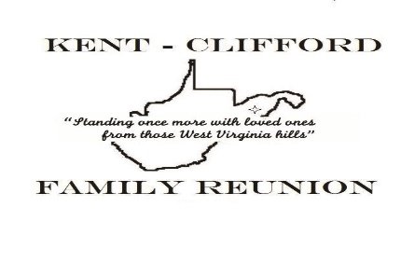
May 1, 2020
Dearest Family,
First and foremost, we on the Kent Clifford Reunion Committee hope everyone is well during this unprecedented national pandemic, COVID-19 virus.
If there is anything we can do to help, please use the Contact Us button on the KentCliffordReunion.com website.
In light of this pandemic and all of the uncertainty that it brings, we have decided to postpone our 2020 Reunion until
next year, August 6-8, 2021. It will still be held in Cumberland, Md at Constitution Park at that time.
Our Charter states the reunion is to be held every two years so the committee will amend the Charter for special circumstances such as this. The family can vote on the amendment at the next family meeting.
There are so many uncertainties regarding this pandemic: folks are out of work, travel restrictions, restrictions on large gatherings. Everything may be straightened out by August but it is not fair to those that have to travel and make arrangements to wait until the last minute for a decision. We want as many family members as possible to attend the reunion.
If there is any news you would like to share with the family while we are apart for another year, please share on the website KentCliffordReunion.com under Family News.
The website is a wonderful way to keep in touch until we can meet face to face. There are pictures of past reunions and many members have posted accomplishments, articles and news of family that we have lost.
We also have a Facebook page: Kent-Clifford Reunion. We encourage you to post and share there also.
I (Joyce, V. President) am writing this letter instead of our President, Marc Stewart because the virus has had an effect on his family. They are on the mend and we are thankful.
We love you all and thank you for your understanding.
Please take care and be safe,
Your Reunion Committee
Marc Stewart, President
Joyce Wormack, V. President
Kamilah Bruce, Treasurer
Karen Stewart, Corresponding Secretary
Kathy Johnson, Recording Secretary
Danene Brown, Webmaster
Yvonne Liser, Historian

