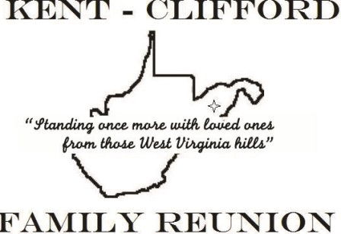KENT CLIFFORD REUNION LETTER
2021-2022 CUMBERLAND, MD
August 2021

Greetings Family,

The reunion date for next year’s reunion is AUGUST 12th, 13th, AND 14th, 2022.

We are praying for everyone during this PANDEMIC. Hopefully we will be able to have the next reunion and see one another.

Plans are being made for the following events. Friday evening –meet and greet. Saturday, we are looking to make it a day at CONSTITUTION PARK in Cumberland, MD, with the reunion meeting and Sunday morning will be the church service, to be determined.
The reunion hotel is Holiday Inn Expess & Suites, Lavale, MD 21502.

Reminder: Dues are due yearly. DUES are $12.00 FOR age 13-64yrs, $6.00 for seniors 65+, $8.00 children 7-12yrs and children under 6 are free. Please mail dues and make payment to KENT CLIFFORD REUNION and mail them to 12501 Prosperity Dr. #320, Silver Springs, MD 20904.

Sincerely,
Prayers and blessings to all!

Marc Stewart
President
Dillmad08@gmail.com
216-632-4424

*********** ENCLOSED IS A ** SAVE THE DATE REMINDER**************

******************SAVE THE DATE*********************

AUGUST 12TH TO THE 14TH, 2022

CONSTITUTION PARK
FORT AVE
CUMBERLAND, MD 21502

